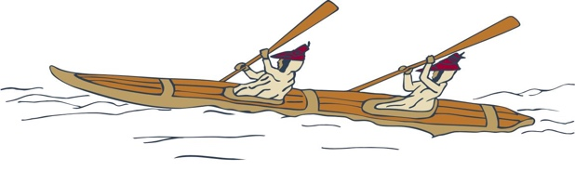
Your career awaits!
Eastern Aleutian Tribes is seeking qualified applicants for a
Community Health Aide Trainee (CHAT).

Working together
to promote healthy communities
Working collaboratively with other healthcare providers and first response teams,
Community Health Aides (CHA) provide primary care (acute, chronic and preventative) and emergency care to a wide variety of patients in his/her assigned village. The Community Health Aide (CHA) program is a tiered program, beginning with the Trainee and advancing through four levels until achieving full certification as CHA Practitioner (CHAP). While on the job, the CHAT will spend a significant amount of time learning via formal and informal instruction, shadowing, self-study, etc. For example, there is a minimum of five training sessions in Anchorage ranging from one-four weeks in duration.

The incumbent is an integral part of the community in which he/she serves; commitment and dedication to continuity and quality of care is imperative for success. Likewise, innovative and creative problem solving, collaboration and patience, and determination are competencies that help define the ideal CHA, whether it’s a Trainee or a fully certified Practitioner.
Join us!
This is a full-time position and can be located in False Pass or Nelson Lagoon.

To compete for this position, candidates must be at least 18 years old and possess:
- High school diploma or equivalent
- Valid Alaska Driver’s License (insurable by EAT)
- Willing and able to travel to Anchorage and/or other training sites to attend basic sessions and other required training for a community health aide.
- Experience working with the Alaska Native Tribal Healthcare System preferred.
- Experience in cross culture setting preferred.

For more information, contact Human Resources, (907) 564-2506. Candidates must submit a thorough CV and a completed employment application found on EAT Careers Page, www.eatribes.org/careers.

Pursuant to PL 93-638, as amended, preference will be given to qualified Alaska Natives, American Indians and/or Eastern Aleutian Tribal Members in all phases of employment.

