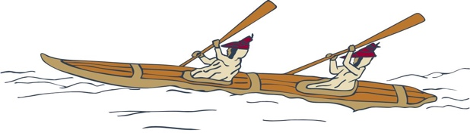
Your career awaits!
Eastern Aleutian Tribes is seeking qualified applicants for a
Community Health Representative.

Working together
to promote healthy communities
The Community Health Representative provides basic non-medical assistance to community members to improve their quality of life. Working in collaboration with the Clinic Manager, Clinic Case Manager and/or Clinic Providers, the Community Health Representative performs a variety of supportive services for community members including basic health education, making home health visits, and providing transportation and/or escorts for patients to their appointments.

Self-discipline, maturity, accountability, and responsibility are critical success factors for this position. Supplementing these competencies is the need for a kind, generous and compassionate individual.
Join us!

This is a full-time position located in King Cove or Sand Point.

To compete for this position, candidates must be 18 years old or older and possess:
- A high school diploma or GED equivalent
- Valid driver’s license (insurable by EAT)
- Basic Life Support (BLS) certification

For more information, contact Human Resources, (907) 564-2506. Candidates must submit a completed employment application found on EAT Careers Page, www.eatribes.org/careers.

Pursuant to PL 93-638, as amended, preference will be given to qualified Alaska Natives, American Indians and/or Eastern Aleutian Tribal Members in all phases of employment.

