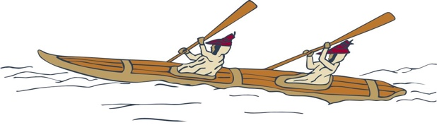
Your career awaits!
Eastern Aleutian Tribes is seeking qualified applicants for a
Behavioral Health Aide Trainee.

Working together
to promote healthy communities
Working collaboratively with a dynamic team, the Behavioral Health Aide Trainee strives to improve the behavioral health and wellness of EAT’s communities. The incumbent serves to orchestrate or facilitate care; he/she schedules patients, ensures patient comfort or safety before, during and post session, helps lead or facilitate sessions, and performs the necessary follow up. He/she takes a pro-active stance on identifying community needs, planning and organizing educational/preventative events, and duplicating throughout the region if necessary.

Respectful but assertive communication, trustworthiness and commitment to the community are requirements for successful patient outcomes. Likewise, the incumbent’s determination, willingness to learn, and patience throughout the certification process are paramount to his/her success in this program. Travel and learning, both formal and informal, certainly are consistent in this trainee role, and the need for enthusiasm and dedication to the health and wellness of a community is constant.
Join us!
This is a full-time position, and can be located in King Cove, Sand Point, Akutan, Cold Bay, False Pass, or Nelson Lagoon.

To compete for this position, candidates must be at least 18 years old and possess:
- High School Diploma or equivalent.
- Willing and able to travel to Anchorage and/or other training sites to attend basic sessions and other required training for a Behavioral Health Aide.
- Chemical Dependency Counselor preferred; incumbent should be able to achieve within first two years of employment.
- Tobacco Cessation Specialist Certification preferred; incumbent should be able to achieve within eighteen months of employment.

For more information, contact Human Resources, (907) 564-2506. Candidates must submit a completed employment application found on EAT Careers Page, www.eatribes.org/careers.

Pursuant to PL 93-638, as amended, preference will be given to qualified Alaska Natives, American Indians and/or Eastern Aleutian Tribal Members in all phases of employment.

